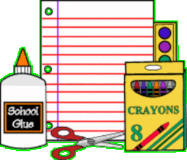
Fifth Grade Wish List
- Homework Calendar/ Planner: This is VERY important to have!
- Pencil Box/Bag for Supplies
- 2 Whiteboard Markers
- Whiteboard Eraser (this could be a clean sock)
- Wide-Ruled Binder Paper (300 sheets)
- 1 1/2"Binder
- 5 Composition Books
- Pack of 12 Pencils (sharpened)
- 2 Packs of Colored Pencils (sharpened)
- Yellow Highlighters
- 3 Black or Blue Ballpoint Pens
- 2 Large Erasers
- Clear Plastic Ruler
- Pocket Dictionary
- 5 Glue Sticks
- Scissors
- Appropriate shoes for PE
- Five divider set

Donations to the Class:
- Ream of white copy paper
- Box of Kleenex
- Bottle of Hand Sanitizer or Clorox Wipes
- Whiteboard Markers
- Brother Toner Dr-820
- Blue/Green Painters Tape

***This is a suggested DONATION wish list. Students are NOT required to bring supplies to school. Donations are appreciated.

